# Project 2 - Computer Vision

Student Name: Shai Cahana

Submission Date: 14/11/24

## **Question 1**

|  |  |
| --- | --- |
| Plot of train/validation accuracy per epoch: |  |
| Plot of train/validation loss per epoch: |  |

## **Question 2**

1. Training for additional epochs would likely be counterproductive, since it seems that the test loss continues to decrease while the validation loss remains the same, which indicates that the model is overfitting. More epochs will increase the overfit, as we can see (will increase the difference between them, and even at some point the validation will start to resemble a U shape!).

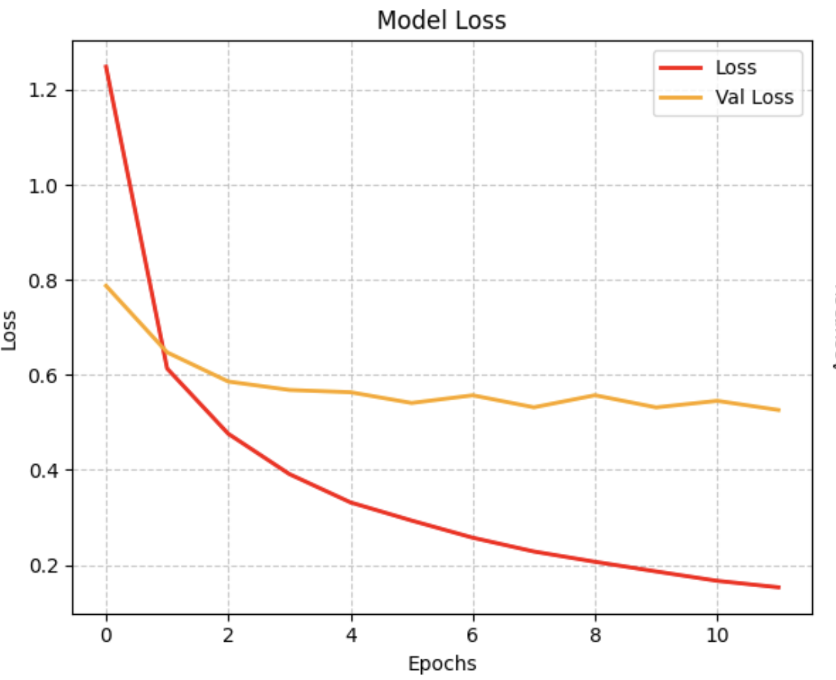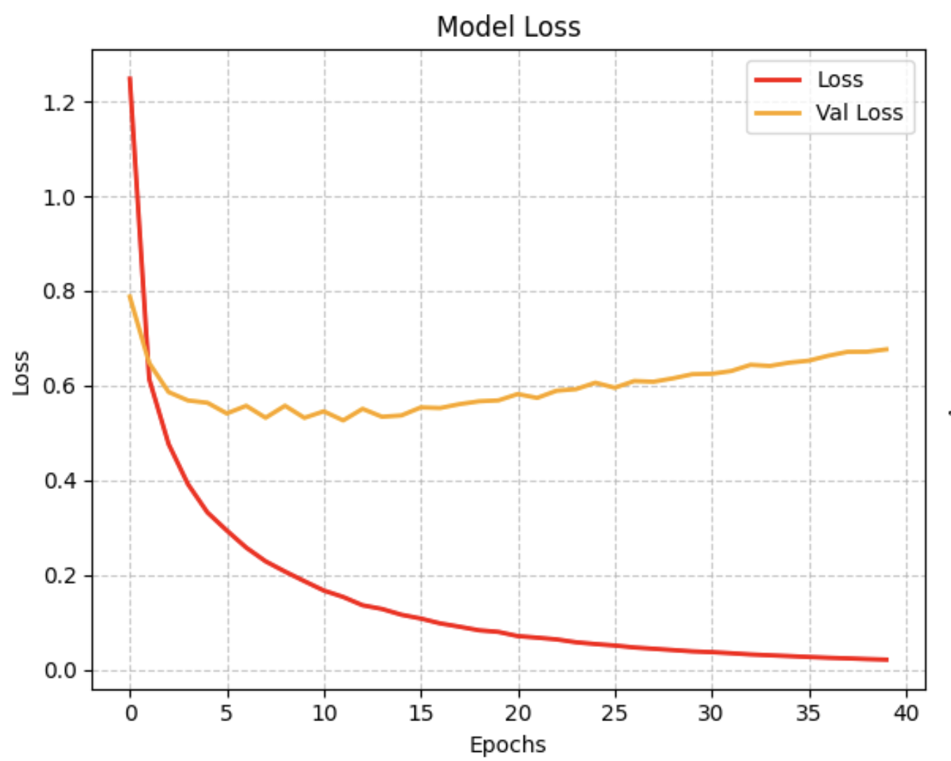  
(Notice the changing number of epochs in the x axis)

1. Increasing the dataset will most likely improve the results because providing more data will help the model learn better patterns and features instead of memorizing the current small dataset.

**Bonus: a graphic explaination**

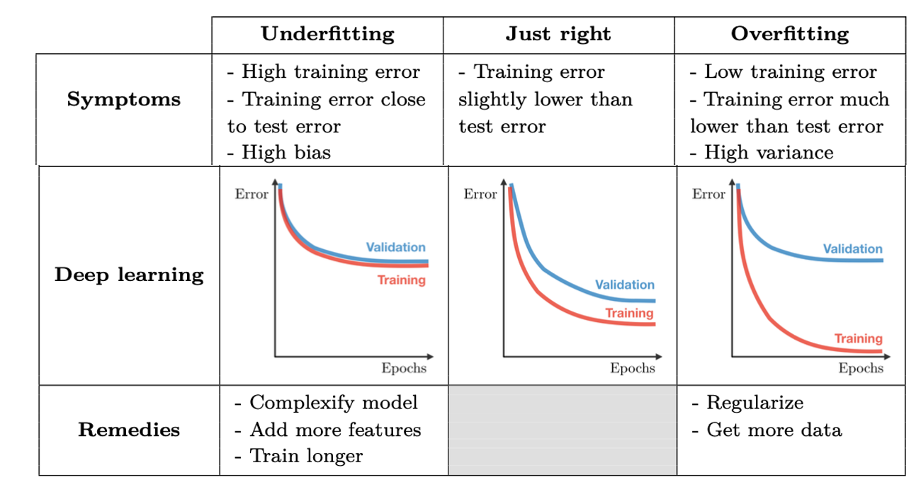

## **Question 3**

|  |  |  |  |  |
| --- | --- | --- | --- | --- |
|  | Training  Time (sec) | Test  Accuracy % | Explain why accuracy has or has not improved | Explain why the training time is slower, faster or hasn’t changed |
| **-** | 19.783 | 77.50 | – | – |
| **A** | 16.3569 | 78.70 | Unfreezing layers allows the network to adapt its pre-trained ImageNet features specifically for CIFAR's characteristics, rather than being limited to using only generic features, **improving accuracy**. | **After unfreezing, we're starting with already-trained weights in the final layer**. Since the network is already "close" to a good solution, it needs fewer training steps to reach optimal performance, therefore the training time is slightly faster. |
| **B** | 16.0851 | 75.60 | Increasing the learning rate can make the model take steps that are too big during training, causing it to miss or jump over the best weights, leading to worse accuracy than a smaller learning rate would achieve. | It's faster because a higher learning rate means bigger weight updates during training without changing the network's structure itself. Like an object moving at higher velocity reaches its destination faster than one moving slowly, though they follow the same path. |
| **C** | 44.3066 | 54.3 | Adding dropout rate of 0.5 to MobileNet with CIFAR-10 decreases accuracy because it disables part of the neurons in the network, and MobileNet's built-in regularization means additional high dropout leads to over-regularization. | Dropout increases training time because it requires extra computational work to randomly disable half the neurons in each training round. The network also needs more training iterations since it's learning with part of it’s features disabled. Additionally, the network must perform extra calculations to scale up the remaining active neurons to maintain the right signal strength. |
| **D** | 44.6794 | 69.4 | Data augmentation improves accuracy by showing the model different versions of the same images, effectively increasing the training set size. It helps the model learn to recognize objects in various situations rather than memorizing specific examples. | The augmentation step slightly increased training time because of the additional data. |
| **E** | 40.4555 | 75.5 | ResNet18 might perform worse because it's overparameterized for CIFAR-10's simple 32x32 image data. MobileNet's depthwise separable convolutions are more parameter-efficient and better suited for smaller images, making it a better fit for this dataset despite being originally designed for mobile devices.  ResNet Test Accuracy: 0.2520  MobileNet Test Accuracy: 0.7970 | The training time is longer compared to the basic MobileNet we started with, this is due to the fast the ResNet18 has significantly more parameters so it takes longer to train. |

I wanted to determine the training for diffrenet number of epochs.

(Left colum epochs=3, right colum epochs=20)



